



**The Grizzly Badgers,**

**Singapore Management University**

**Ang Mo Kio - Thye Hua Kwan Hospital**

**Functional Specifications**

**Visitor Logging – Check-in Module**

**Stepwise**

**v1.0**

**24 October 2016**

**Revision History**

|  |  |  |  |  |  |
| --- | --- | --- | --- | --- | --- |
| **Version** | **Effective Date** | **Summary of Change** | **Prepared by** | **Reviewed by** | **Approved by** |
| 1.0 | 24/10/2016 | Initial Version | Yu Zheng Yuan |  |  |
| 1.1 | 18/12/2016 | Updated Business Process for Visitor Online Self-Registration | Yu Zheng Yuan |  |  |
| 1.2 | 22/12/2016 | Updated Business Logic | Yu Zheng Yuan |  |  |

Contents

[1) Introduction 4](#_Toc470195085)

[2) Overview of Visitor Logging 4](#_Toc470195086)

[3) Functional Requirements 4](#_Toc470195087)

[4) Process and Business Rule 5](#_Toc470195088)

[5) Error and Message Handling 7](#_Toc470195089)

[6) Access Control 8](#_Toc470195090)

[Appendices 9](#_Toc470195091)

## Introduction

* 1. We aim to improve the existing visitor registration process by reducing the amount of manual tasks needed to capture the visitor information.

## Overview of Visitor Logging

* 1. Visitors will now have the option to register their visit online before they enter the hospital. It will reduce the time needed to queue up and it reduces the workload for the front desk staff as they will now only be required to help take the visitor’s temperature and check if the ward’s visiting capacity is at a reasonable limit to enter.

## Functional Requirements

* 1. Stepwise Visitor Logging provides the following key functions to facilitate the registration of visitor:
     1. Visitor Online Self-Registration / Assisted Registration
        1. The Visitor Online Self-Registration will be a website that is accessible on the hospital’s website for visitors to register their visit online. But if visitors do not register beforehand, the front desk staff would be able to do so by helping to register a new visit by the assisted registration page.

## Process and Business Rule

* 1. **Process Flow for Visitor Online Self-Registration / Assisted Registration (As-is)**

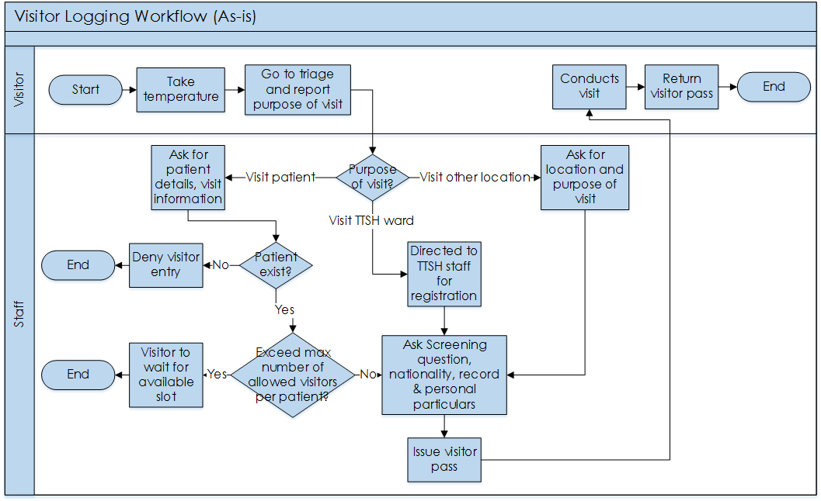

* 1. **Process Flow for Visitor Online Self-Registration / Assisted Registration (To-be)**

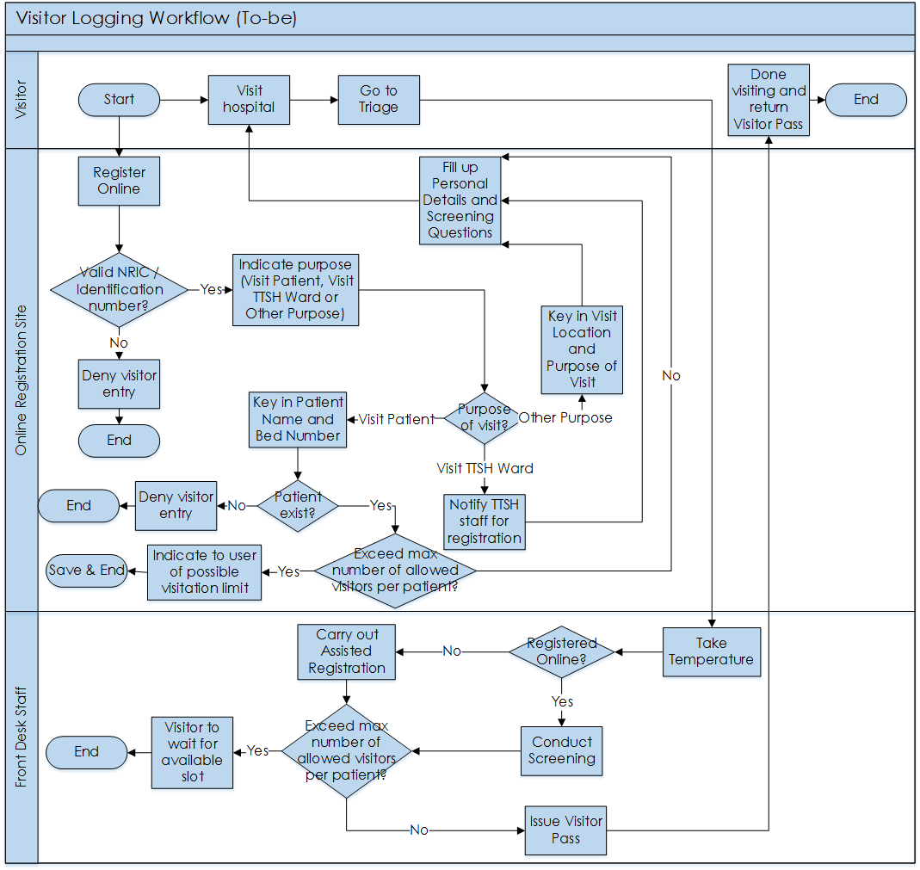

## Error and Message Handling

| **Error Code** | **Error Message** | **Remarks** |
| --- | --- | --- |
| 1001 | System Error. Please contact the system administrator. |  |
| 1002 | This item is mandatory. |  |
| 1003 | Invalid NRIC/FIN number. |  |
| 1005 | Please enter a valid Contact Number. |  |
| 1006 | Please enter Mobile Number in digits. |  |
| 1007 | Patient information is wrong |  |
| 1008 | Please enter valid Email address |  |
| 1009 | Please enter Postal Code in digits |  |
| 1010 | Please enter Postal Code in temperature |  |

## Access Control

Access Control have been implemented for the adminstration portal and there are a total of 5 levels and each level allows the user of the system to access certain function of the portal as it is shown below in the table:

|  |  |  |
| --- | --- | --- |
| Level | Function Allowed to Access | Remarks |
| 1 | Registration |  |
| 2 | Form Management |  |
| 3 | Terminal Management |  |
| 4 | Pass Management |  |
| 5 | Reserved for additional funcationality |  |

It works by assigning the user different level to access certain portion of the application. For instance, user with level 1, 2 and 3 will be able to access Registration, Form Management and Terminal Management.

It is done this way to allow easy management and flexibility to control the users. The adminstrator can easily assigned the level user or remove the level to each individual.

## Appendices

|  |
| --- |
| **Screen 1.1 Visitor Online Self-Registration Window (Homepage)** |
| **C:\Users\yzy\Downloads\Telegram Desktop\AMHTHKH_ScreenShots\AMHTHKH_ScreenShots\SelfRegistrationP1.PNG** |

|  |  |  |  |  |  |  |  |
| --- | --- | --- | --- | --- | --- | --- | --- |
| **Table 1.1 Visitor Online Self-Registration Window (Homepage)** | | | | | | | |
| **Name** | **UI Element Type** | **Size** | **Mandatory?** | **Default** | **Format** | **Validation** | **Error Message** |
| NRIC/FIN | Textbox | - | Y | - | Varchar | Valid NRIC/FIN number | 1003 |

|  |
| --- |
| **Screen 1.2a Visitor Online Self-Registration Window (Visit Details Page– Visit Patient Option)** |
|  |

|  |  |  |  |  |  |  |  |
| --- | --- | --- | --- | --- | --- | --- | --- |
| **Screen 1.2a Visitor Online Self-Registration Window (Visit Details Page– Visit Patient Option)** | | | | | | | |
| **Name** | **UI Element Type** | **Size** | **Mandatory?** | **Default** | **Format** | **Validation** | **Error Message** |
| Visit Purpose | Dropdown | - | Y | - | Varchar | - | - |
| Patient Name | Textbox | - | Y | - | Varchar | Valid patient | 1007 |
| Bed Number | Textbox | - | Y | - | Varchar | Valid bed number | 1007 |
| Visit Date | Calendar | - | Y | - | Date | - | - |
| Visit Time | Time | - | Y | - | Time | - | - |
| Validate Patient Information | Button | - | - | - | - | - | - |

|  |
| --- |
| **Screen 1.2b Visitor Online Self-Registration Window (Visit Details Page - Other Purpose Option)** |
|  |

|  |  |  |  |  |  |  |  |
| --- | --- | --- | --- | --- | --- | --- | --- |
| **Screen 1.2b Visitor Online Self-Registration Window (Visit Details Page - Other Purpose Option)** | | | | | | | |
| **Name** | **UI Element Type** | **Size** | **Mandatory?** | **Default** | **Format** | **Validation** | **Error Message** |
| Visit Purpose | Dropdown | - | Y | - | Varchar | - | - |
| Visit Location | Dropdown | - | Y | - | Varchar | - | - |
| Purpose of Visit | Textbox | - | Y | - | Varchar | - | - |
| Visit Date | Calendar | - | Y | - | Date | - | - |
| Visit Time | Time | - | Y | - | Time | - | - |

|  |
| --- |
| **Screen 1.3 Visitor Online Self-Registration Window (Visit Details Page - Personal Details)** |
|  |

|  |  |  |  |  |  |  |  |
| --- | --- | --- | --- | --- | --- | --- | --- |
| **Screen 1.3 Visitor Online Self-Registration Window (Visit Details Page - Personal Details)** | | | | | | | |
| **Name** | **UI Element Type** | **Size** | **Mandatory?** | **Default** | **Format** | **Validation** | **Error Message** |
| Full Name | Textbox | - | Y | - | Varchar | No validation | - |
| Email Address | Textbox |  | N | - | Varchar | Valid email address | 1008 |
| NRIC/FIN | Textbox | - | Y | - | Varchar | Valid NRIC/FIN number | 1003 |
| Mobile Number | Textbox | - | Y | - | Number | Valid mobile number | 1006 |
| Alternate Number | Textbox | - | N | - | Number | Valid mobile number | 1006 |
| Address | Textbox | - | Y | - | Varchar | No validation | - |
| Postal Code | Textbox | - | Y | - | Number | Valid postal code | 1009 |
| Gender | Dropdown | - | Y | - | Varchar | - | - |
| Nationality | Dropdown | - | Y | - | Varchar | - | - |
| Date of Birth | Calendar | - | Y | - | Date | - | - |

|  |
| --- |
| **Screen 1.4 Visitor Online Assisted Registration Window (Login Page)** |
|  |

|  |  |  |  |  |  |  |  |
| --- | --- | --- | --- | --- | --- | --- | --- |
| **Screen 1.4 Visitor Online Assisted Registration Window (Login Page)** | | | | | | | |
| **Name** | **UI Element Type** | **Size** | **Mandatory?** | **Default** | **Format** | **Validation** | **Error Message** |
| Username | Textbox | - | Y | - | Varchar | No validation | - |
| Password | Textbox |  | Y | - | Varchar | No validation | - |
| Login | Button | - | - | - | - | - | - |
| Check-In Terminal | Button | - | - | - | - | - | - |

|  |
| --- |
| **Screen 1.5 Visitor Online Assisted Registration Window (Search and Temperature Page)** |
|  |

|  |  |  |  |  |  |  |  |
| --- | --- | --- | --- | --- | --- | --- | --- |
| **Screen 1.5 Visitor Online Assisted Registration Window (Search and Temperature Page)** | | | | | | | |
| **Name** | **UI Element Type** | **Size** | **Mandatory?** | **Default** | **Format** | **Validation** | **Error Message** |
| NRIC/FIN | Textbox | - | Y | - | Varchar | Valid NRIC/FIN number | 1003 |
| Temperature | Textbox | - | N | - | Number | Valid temperature | 1010 |
| Check NRIC | Button | - | - | - | - | - | - |

|  |
| --- |
| **Screen 1.6 Visitor Online Assisted Registration Window (Personal Details and Visit Details Page)** |
|  |

|  |  |  |  |  |  |  |  |
| --- | --- | --- | --- | --- | --- | --- | --- |
| **Screen 1.6 Visitor Online Assisted Registration Window (Personal Details and Visit Details Page)** | | | | | | | |
| **Name** | **UI Element Type** | **Size** | **Mandatory?** | **Default** | **Format** | **Validation** | **Error Message** |
| Full Name | Textbox | - | Y | - | Varchar | No validation | - |
| Email Address | Textbox |  | N | - | Varchar | Valid email address | 1008 |
| NRIC/FIN | Textbox | - | Y | - | Varchar | Valid NRIC/FIN number | 1003 |
| Mobile Number | Textbox | - | Y | - | Number | Valid mobile number | 1006 |
| Alternate Number | Textbox | - | N | - | Number | Valid mobile number | 1006 |
| Address | Textbox | - | Y | - | Varchar | No validation | - |
| Postal Code | Textbox | - | Y | - | Number | Valid postal code | 1009 |
| Gender | Dropdown | - | Y | - | Varchar | - | - |
| Nationality | Dropdown | - | Y | - | Varchar | - | - |
| Date of Birth | Calendar | - | Y | - | Date | - | - |